International Plaza A
- Double room with single bed
- Private bathroom
- Room with refrigerator: 85 RMB/Day/Person
- Room without refrigerator: 80 RMB/Day/Person
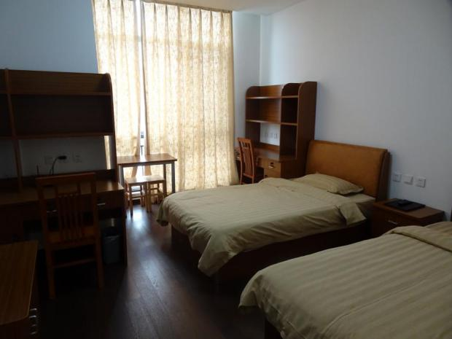
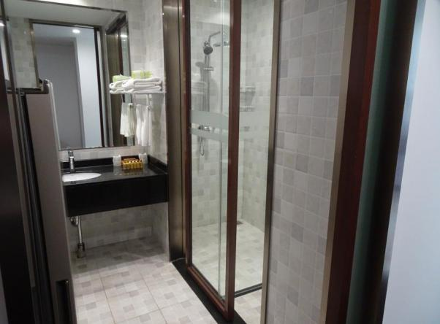

* The picture is for reference ONLY. The actual room may differ.

Huicai Apartment (Building #5)
- Triple room with single bed
- Private Bathroom
- 50 RMB/Day/Person
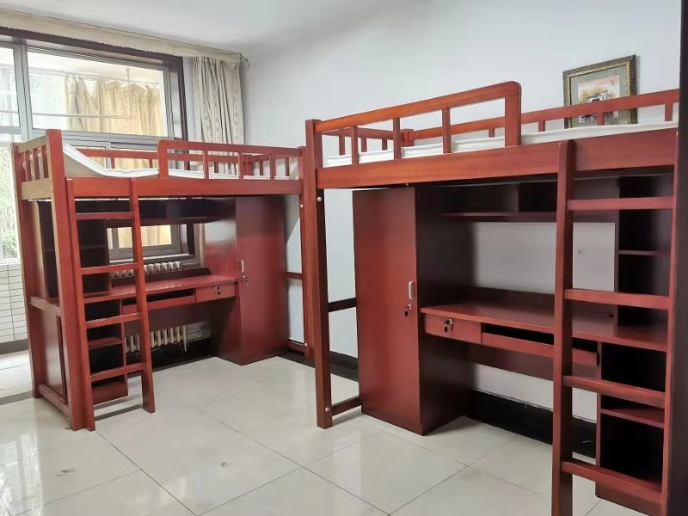
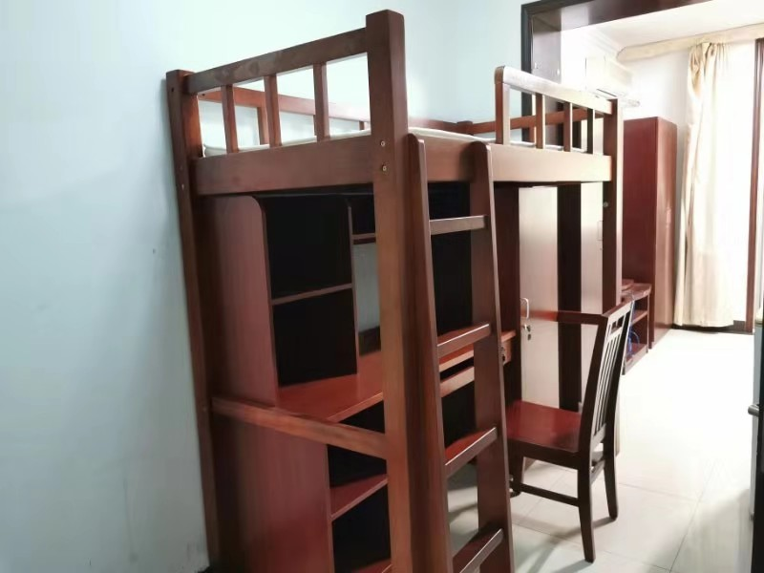

* The picture is for reference ONLY. The actual room may differ.

Off-Campus Hotel（10-30 minutes to campus）
- Double room with single bed
- Private bathroom
- 80 RMB/Day/Person

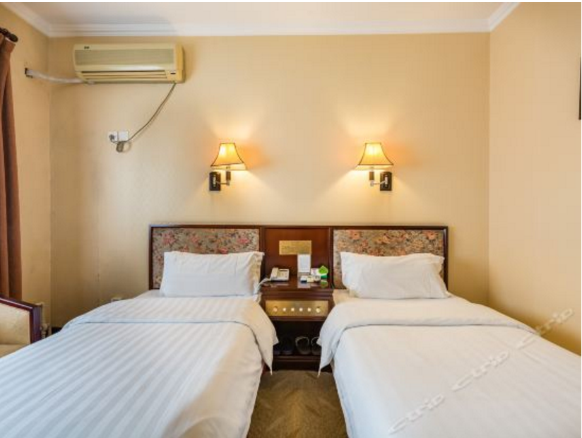
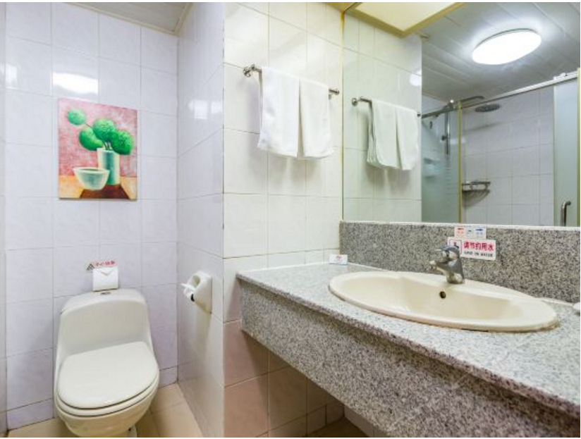

* The picture is for reference ONLY. The actual room may differ.

