Guideline for 2019 Spring Semester (Feb.20- June 30, 2019)

University of International Business and Economics

对外经济贸易大学

2019年春季学期交流指南
Global Exchange and Experience Center (GEEC)
Room 201, International Plaza B Wing, University for International Business and Economics

http://geec.uibe.edu.cn/ywsy/index.htm

Content
WELCOME - - - - - - - - - - - - - - - - - - - - - - - - - - - - - - - - - - - - -1
NOMINATION & APPLICATION - - - - - - - - - - - - - - - - - - - - 2
ACCOMMODATION - - - - - - - - - - - - - - - - - - - - - - - - - - - - - 3
COURSE REGISTRATION - - - - - - - - - - - - - - - - - - - - - - - - -4
VISA APPLICATION - - - - - - - - - - - - - - - - - - - - - - - - - - - - -6
MAP OF CAMPUS - - - - - - - - - - - - - - - - - - - - - - - - - - - - - - - 8
MAP AROUND UIBE- - - - - - - - - - - - - - - -— - - - - - - - - - - -9
LIFE IN UIBE - - - - - - - - - - - - - - - - - - - - - - - - - - - - - - - - - - 10
THE END - - - - - - - - - - - - - - - - - - - - - - - - - - - - - - - - - - - - - 11

Hello! I am the Global Exchange and Experience Center at the University of International Business and Economics (UIBE). Welcome to UIBE!
Here I would like to introduce myself briefly. I am the one who will be in charge of your life and study at UIBE. So in this guideline, I have listed all of the useful information for you.

Welcome
1
Procedures:
- Apply for exchange program with your home university. Ask your coordinator to send your information to
incoming.uibe2016@yahoo.com before the deadline. An official nomination letter from partner university is needed.
- Log on the website and finish the on-line application in due time.
http://www.uibe.cn/app/eng/
- Application Guidance:
http://geec.uibe.edu.cn/ywsy/programs/internationalexchange/applications/61286.htm
- All applicant must have valid passport to cover whole exchange program. If not, please have it renewed before nomination and online application.
- Technical Support: Please contact our admissions office for support via sie@uibe.edu.cn
- Wechat Account
Each exchange student is required to have a WeChat account. Please download this app from app store or android market on your mobile. Add Contacts: “UIBE_Incoming” with Remark of NAME+2019S+Home University. It has to be finished before Dec. 31, 2018.
- Mailing Admission Letter. Admission letter and other visa application materials will be mailed to your home university no later than Jan.15, 2019.

Nomination & Application
Deadline:
Nomination: Oct.30, 2018
Online Application: Now till Nov. 11, 2018
Note:

xdf
Documents Delivery: April 15th,2015

Documents Delivery : April 15th, 2015

2
Our new dormitory will be open to our exchange students soon, and accommodation application for 2019 Spring semester now available. Please note the follow issues for staying on campus:
1. Room Type and rate:
Double room with two single beds
Double rooms are located in Huibin Apt., Huicai Apt., Huide Apt. and new International Education Building
Rate range: 35-90 RMB/ Day/ Person
2. Application and confirmation:
- The application will start after we get all nomination and the final confirmation will be posted to the website in November 2018. http://geec.uibe.edu.cn/ywsy/eventsnew/index.htm
- Own arrangement accepted. On-campus accommodation application is not a must for every exchange student. If you have your own arrangement, please DO NOT email your application to us. If you don’t have your own arrangement and fail to email your application, we will assume you have your own arrangement.

Accommodation
3
Instruction
Course registration is a must for your study in UIBE. Rules:
- Registration module (choose ONLY one module ):
A. no more than 6 business or economic courses
B. 20-hour Chinese course + 2 other business or economic courses
C. 6-hour Chinese course+4 other business
MBA539 Business Chinese is a complimentary course for any module.
- Credit Transfer
Normally, 1 local credit = 2 ECTS.
But it various according to the policy from your own home university.
- Courses are provided by 3 faculties/schools:
School of International Education (SIE)
School of International Trade and Economics (SITE)
Business School (BS)
- Learning Agreement
The Learning agreement (LA) is the only document that serves a proof of your course registration. Each student is required to fill out the agreement carefully.
- Procedures for Course Registration
20-HOUR Chinese Course:
Register it when you finish your status registration.
Dropping this course after taking the test is not allowed.
6-Hour Chinese Course: To be announced in September.

Course Registration
4
Business Courses
STEP ONE: Finish Status Registration no later than Feb.22, 2019
STEP TWO: Download learning agreement and check course schedule from GEEC website
STEP THREE: Try courses (SIE, SITE, BS) you are interested in
STEP FOUR: Make your final decision and fill them out in your learning agreement
STEP FIVE: Submit your learning agreement before the deadline

Note:
Status Registration: Confirm your status as an exchange students
Learning Agreement: A form for course registration, and once fill it in no more change will be accepted.
Course Information: Course information will be posted to our website when they are confirmed by three teaching colleges.

Grades and Transcripts
Grades will be posted to our web page by the end of the semester.
Transcripts will be made and mailed directly to your home university by the beginning of 2019 Fall Semester (September).
5

The Chinese government issues different visas to foreigners wishing to enter China according to their purposes of visit. The visas are marked Chinese phonetic letters of D, Z, X1, X2, L, G or C; those for international students are marked X1 (for study 6 months or more) or X2(for study less than 6 months). When you apply the Chinese visa at Chinese embassy or consulate, you should submit the Acceptance Letter (Admission Letter) and the Visa Application Form (JW202) issued by UIBE and the Government of Beijing.
Students who hold “Type X1” Visa need to apply for the “Residence Permit” in Beijing within 30 days after your arrival and go for a medical checkup. The School of International Education (SIE) shall assist you with the visa-related matters.
For students who are not able to get the visa in time can apply for a tourist Visa first and change it into “X1” or “X2” Visa after arriving at UIBE.
Should you need any further information concerning Visa, please call +86(0)10-6449-5563.

Insurance
According to the regulations of the Chinese Ministry of Education, students of Non-Degree Programs MUST have a China insurance to register besides the insurance from your home country. You need to buy insurance when you register at SIE. It will cost 300 RMB for 6 months or 600RMB for a year. Cash Only.

Visa Application
6

NOTICE OF VISA EXTENSION / RENEWAL & MULTIPLE ENTRY APPLICATION

1. Students who hold the X2 visa that cannot cover the whole semester,
● Please go to Room 102, International Plaza B Wing, UIBE in March, 2019
● For X2 visa extension, please take
a. Registration form of Temporary Residence
b. Recent passport photo, 2-inch, white background, no hat
c. Admission notice & JW202
d. Corresponding visa application fee (the fee differs from country to country)
● Please collect your passport 2 weeks after the application date

2. Students who need to multiply entries,
● Please go to Room 102, International Plaza B Wing, UIBE, at least 3 months before the completion of your study in UIBE (for autumn semester students, the deadline to apply for 2 entries is April 28, 2019; 1 entry, May 30, 2019.)
● Maximum two entries
● For entries multiplying, please take
a. Registration form of Temporary Residence
b. Recent passport photo, 2-inch, white background, no hat
c. Admission notice & JW202
e. Corresponding visa application fee (the fee differs from country to country)
f. A detailed traveling plan (with the flight tickets)
● Please collect your passport 2 weeks after the application date

3. Students who hold the X1 visa
● Please change the X1 visa to Residence Permit as soon as you arrive in China, as this type of visa only allow you to stay here for 30 days.
● For Residence Permit application, please take
a. Registration form of Temporary Residence
b. Recent passport photo, 2-inch, white background, no hat
c. Admission notice & JW202
d. Certificate of Verification for Physical Examination Record for Foreigner or Overseas Chinese (please ask for the map of Beijing International Travel Healthcare Center Haidian clinic in the Room 102
● RMB 500 (No EXPRESS)
● Please collect your passport 15-20 days after the application date

4. Students who need to use the passport during the visa application procedures
● Please raise a claim on the day of visa application for a Yellow Receipt, otherwise, the receipt cannot get from the Visa Bureau.
● The Yellow Receipt (VISA/STAY PERMIT/RESIDENCE PERMIT APPLICATION RECEIPT) could certify that your passport is in application temporarily (for taking a train or living in a hotel in mainland China).
● Please take the Yellow Receipt to collect your passport at the EXIT AND ENTRY ADMINISTRATION DIVISION OF BEIJING MUNICIPAL PUBLIC SECURITY BUREAU
7
Map of Campus

8

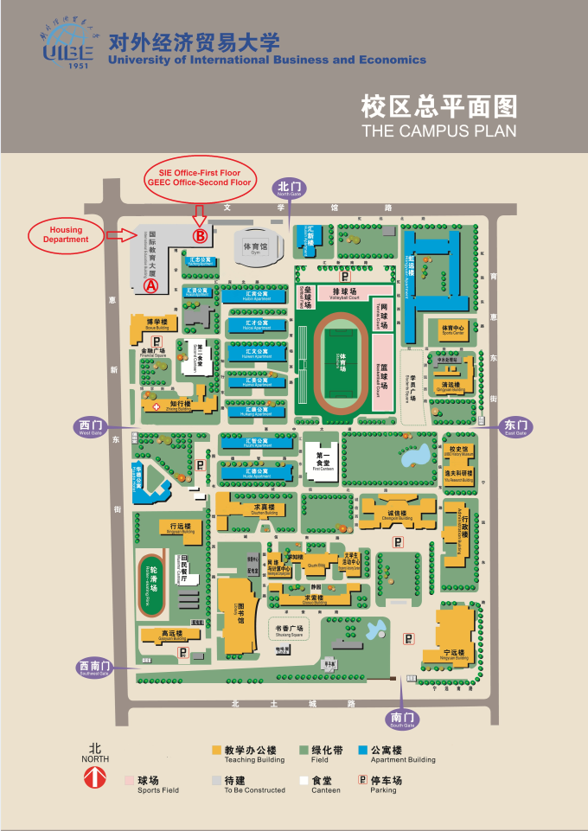
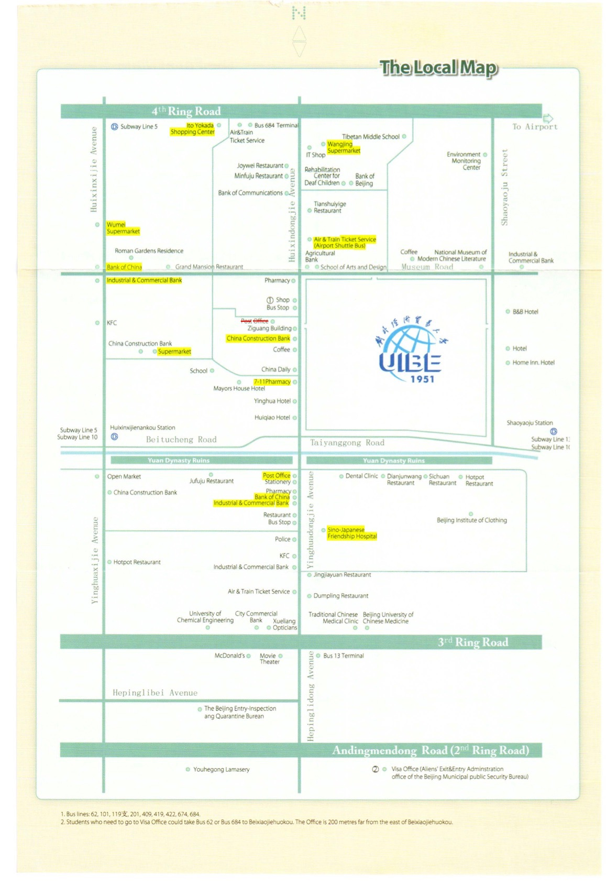
Map around UIBE
9
Life in UIBE
Transportation:
AIR PICK-UP: At fixed time (not finalized)
Airport Shuttle Bus : From 18RMB/PERSON
Airport Express: 25RMB/PERSON(TO SANYUANQIAO STATION)
Taxi: No more than 100RMB
WIFI:
Username and password will be given when semester begins.
Free for China’s websites and charge for International non-educational websites (20RMB/month).
Meal:
Students will get E-card (campus card) when semester starts.
E-card can be used in cafeterias, and certain on-campus stores and library.
Gym:
An underground gym managed by School of International Education.
New gym was newly built with various events.
10
UIBE
11
GEEC
Tel: +86(0)10-6449-2121
Email: incoming.uibe2016@yahoo.com
Address: Rm.201, B Wing, International Plaza
University of International Business and Economics
No.10, HuixinDongjie
Chaoyang District, Beijing
100029, China

Please find more detailed information from our web page:
http://geec.uibe.edu.cn/ywsy/index.htm

