Chinese Economic Law

Synopsis
This course examines the framework and principles of policy and jurisprudence regulating economic activities in the People’s Republic of China. Particular focus is placed on the branches of substantive laws that affect trade, investment, and financial and commercial transactions. Cultural and ethical foundations will be discussed to enhance the understanding into the Chinese legislative and judicial processes. A number of cases will be deployed for class debate to gain insight into the intrinsic application of Chinese laws in business decisions and dispute settlement.

Objective
This course is to foster the understanding and application of Chinese economic laws and regulations for business decision-makers.

Outline
- Forces that shape Chinese law
- Political system and economic reform
- Chinese cultural and ethical foundations
- Statutory organizations and process
- Institutional structure
- Legislative process
- Framework of Chinese law
- Substantive law
- Procedural law
- Sources and principles of Chinese economic law
- Constitution and amendments
- Civil code
- International commitment
- Chinese law of contract
- UNSIG
- Contract law
- WTO commitment
- Chinese investment law
- Regulation on direct investment
- Regulation on portfolio investment
- Chinese law on consumer protection
- Consumer rights
- CSR enforcement
- Chinese laws on intellectual properties
- IPRs and violation
- Recourse on IP infringement
- Dispute settlement
- Arbitration
- Litigation
- Examination

Evaluation
Attendance 10%
Participation 10%
Homework 30%
Exam 50%

_____________________________________________________________________
Instructor: Baocheng Liu
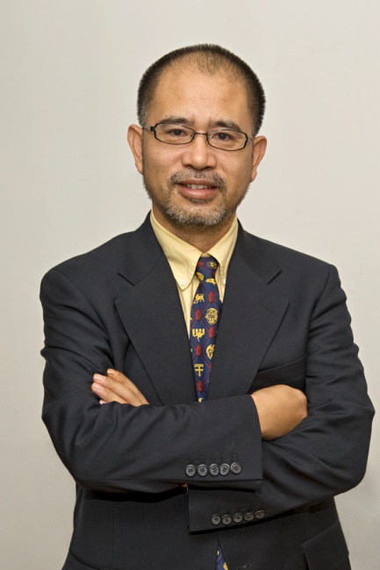
Director, Center for International Business Ethics,
University of International Business and Economics, China, and
Current Affairs Commentator, CCTV-News
baocheng.liu@gmail.com
Dr. Liu earned his MBA and MSc in International Business from Seton Hall University, bachelor degree in International Trade and PhD in Law from University of International Business and Economics(UIBE). He was the founder and dean to Sino-US School of International Management and Sino-French School of International Management after serving as the executive associate dean for the International School of Excellence at UIBE. His area of research and teaching covers a variety of disciplines including marketing, business ethics, cross-cultural communication and business law.
He is the winner of National Teaching Excellence Award in 2008.
Dr. Liu published extensively in the area of international business, ethics and law.
Besides research and teaching, he served on the management of London Export Corporation, Union Merchant Overseas Corporation and Cathay Trading Ltd, president and CEO of Unigene Biotechnology Inc., Chief Representative of Herborium Inc., and Chairman of Novark Consulting. His hands-on business experience covers international trade, joint venture management, marketing research and legal service. He also serves as legal council to Bairui Law Firm in Beijing.
He is on the council of World Economic Forum, advisory board to the Department of European Affairs under Ministry of Commerce and China Foreign Expert Bureau, member of China Social and Economic Council, Council Member of China Business Ethics Society.
As current affairs commentator, he regularly voices his opinions on CCTV, VOA, BBC and CRI.

